## 3.3. Photos & 3D Drawings

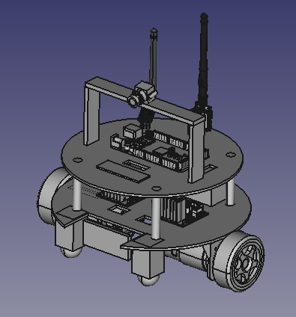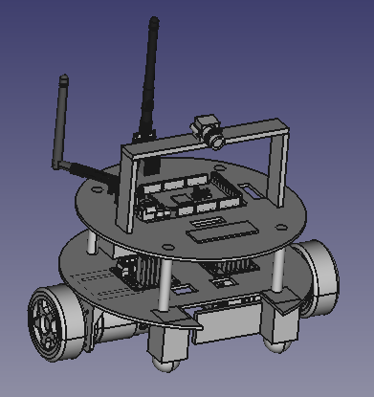 3D Drawings and real photos of the robot can be seen in Figure xx & xx.

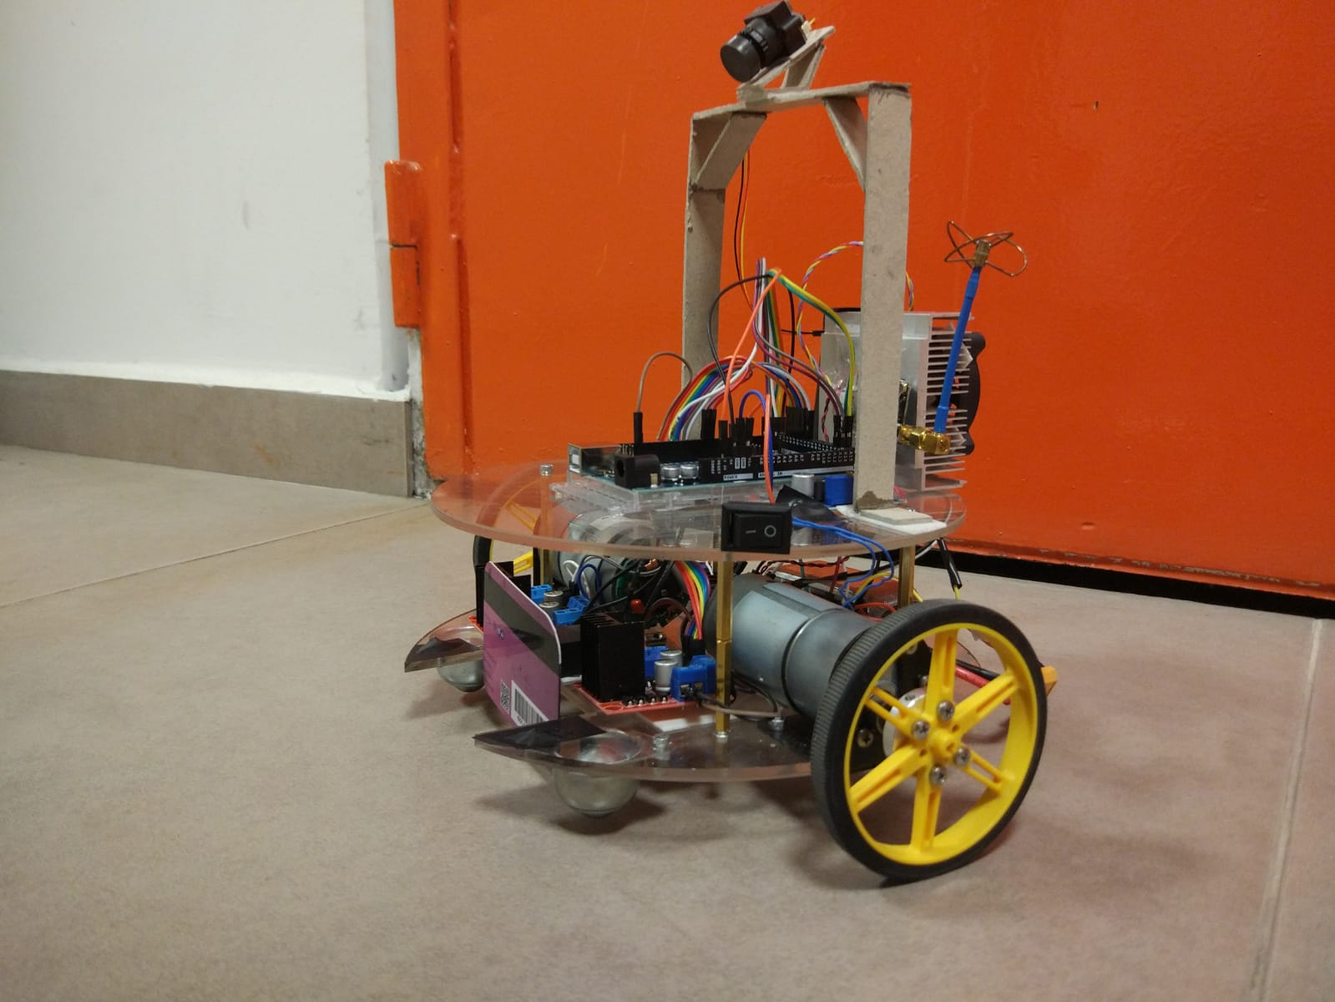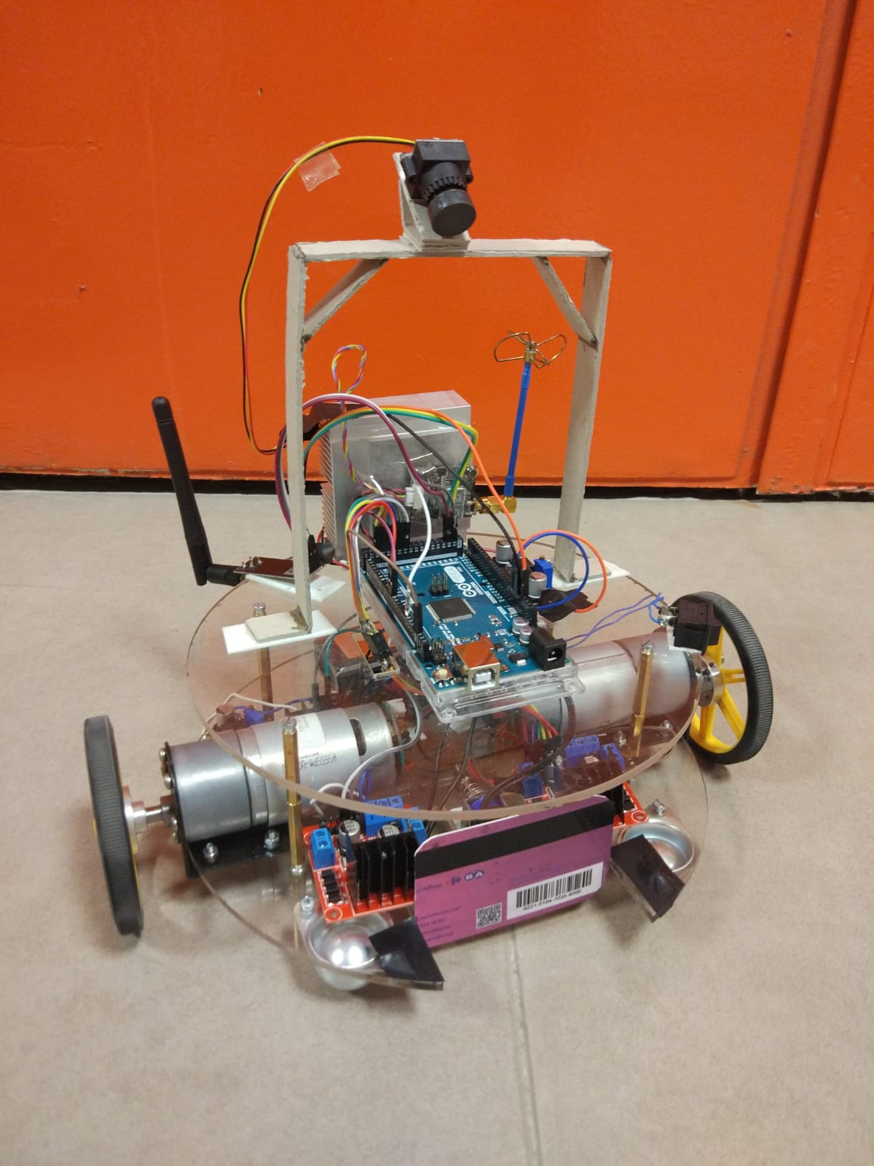Figure : 3D Drawings of the Robot

Figure : Photos of the Robot

### 4.1.4. Motion Subsystem Test and Results

We optimized our design considering the 20 sec restriction and also the amount of time we can play with a fully charged LiPo battery. Initially we tried increasing the speed incrementally. After some trials within the playfield we saw that it takes a lot of time to drive the robot to a desired location with this adjustment. Therefore, we decided to increase the number of commands rather than increasing the speed incrementally. Since we have a joystick on the controller side, we increased our direction commands to eight. There is one middle speed and also full speed value for each direction. This adjustment enabled us to perform small operations. As we mentioned earlier, the velocity of our robot is approximately 45 cm/sec at its full speed which is highly enough to comply with 20 sec restriction.

We also checked our final design after implementing the above-mentioned adjustment to see the stability of the robot during a real game. Since we have middle speed values, stability during small operations is highly increased. In addition to stability we also observed the heat generated by the motors after one full operation. Since we are not forcing DC motors too much, they don’t even get hot therefore the mechanic strain on the DC motors can be neglected.

#### Appendix A

#### Arduino Code

Transmitter Side (Arduino Uno):

#include <SPI.h>

#include "nRF24L01.h"

#include "RF24.h" //Modül ile ilgili kütüphaneleri ekliyoruz

RF24 verici**(**9**,**10**);** //kütüphane tarafından kullanılacak pinleri tanımlıyoruz (CE,CSN)

const uint64_t kanal **=** 0xE8E8F0F0E1LL**;** //kanalı tanımlıyoruz

int joystick_x_pin **=** A0**;**

int joystick_y_pin **=** A1**;**

int joystick_switch_pin **=** A2**;**

int joystick_x**=**0**;**

int joystick_y**=**0**;**

int joystick_switch **=** 0**;**

int message**[**1**]** **;**

void setup**(**void**)**

**{**

Serial**.**begin**(**9600**);**

verici**.**begin**();** //nrf yi başlatıyoruz

verici**.**openWritingPipe**(**kanal**);** //kanal id si tanımlanıyor

**}**

void loop**(**void**)**

**{**

//Reading commands from joystick

joystick_x **=** analogRead**(**joystick_x_pin**)-**512**;**

joystick_y **=** analogRead**(**joystick_y_pin**)-**512**;**

joystick_switch **=** analogRead**(**joystick_switch_pin**);**

**if(**joystick_y**>**400**){**

message**[**0**]=**B00000010**;**  // ”sağ” komutu

**}**

**else** **if** **(**joystick_y**<-**400**){**

message**[**0**]=**B00000001**;** // ”sol” komutu

**}**

**else** **if** **(**joystick_x**>**400**){**

message**[**0**]** **=** B00001000**;** // ”ileri” komutu

**}**

**else** **if** **(**joystick_x**<-**400**){**

message**[**0**]=**B00000100**;** // ”geri” komutu

**}**

**else** **if** **(**joystick_switch **<**50**)** **{**

message**[**0**]=**B00010000**;** // ”shoot” komutu

**}**

**else** **if** **(**joystick_y**<**450 **&&** joystick_y**>**100**){**

message**[**0**]=**32**;** // ”yavaş sağ” komutu

**}**

**else** **if** **(**joystick_y**<-**100 **&&** joystick_y**>-**450**){**

message**[**0**]=**64**;** // ”yavaş sol” komutu

**}**

**else** **if** **(**joystick_x**>**100 **&&** joystick_x**<**450**){**

message**[**0**]** **=** 9**;** // ”yavaş ileri” komutu

**}**

**else** **if** **(**joystick_x**<-**100 **&&** joystick_x**>-**450**){**

message**[**0**]=**5**;** // “yavaş geri” komutu

**}**

**else** **{**

message**[**0**]=**B00000000**;** //”dur” komutu

**}**

verici**.**write**(**message**,** 1**);** //mesaj değişkeni yollanıyor

Serial**.**print**(**message**[**0**]);**

**}**

Receiver Side (Arduino Mega):

#include <SPI.h>

#include <Servo.h> //Servo kütüphanesini ekledik.

#include "nRF24L01.h"

#include "RF24.h"

#define enA 2

#define enB 3

#define in1 24

#define in2 26

#define in3 28

#define in4 30

#define in5 32

#define in6 34

int mesaj**[**1**];**

RF24 alici**(**9**,**53**);** //CE,CSN

const uint64_t kanal **=** 0xE8E8F0F0E1LL**;** //kanalı tanımlıyoruz

bool sag **=** false**;**

bool sol **=** false**;**

bool ileri **=** false**;**

bool geri **=** false**;**

bool shoot **=** false**;**

String karar **;**

int i**;**

void setup**(**void**){**

Serial**.**begin**(**9600**);**

alici**.**begin**();**

alici**.**openReadingPipe**(**1**,**kanal**);**

alici**.**startListening**();** //gönderilen veri için dinlemeye başlıyor

pinMode**(**enB**,** OUTPUT**);**

pinMode**(**enA**,** OUTPUT**);**

pinMode**(**in1**,** OUTPUT**);**

pinMode**(**in2**,** OUTPUT**);**

pinMode**(**in3**,** OUTPUT**);**

pinMode**(**in4**,** OUTPUT**);**

pinMode**(**in5**,** OUTPUT**);**

pinMode**(**in6**,** OUTPUT**);**

**}**

void loop**(**void**){**

**if** **(**alici**.**available**())**

**{**

bool done **=** false**;**

done **=** alici**.**read**(**mesaj**,** 1**);** //okunan veri mesaj değişkenine yazılıyor

**if** **(**mesaj**[**0**]==**5**){**

karar **=** "yavaş geri"**;**

analogWrite**(**enA**,** i**);** //pwm değeri girme 1.motor için

analogWrite**(**enB**,** i**);** //pwm değeri girme 2.motor için

digitalWrite**(**in1**,** HIGH**);** //yön belirleme

digitalWrite**(**in2**,** LOW**);**

digitalWrite**(**in3**,** HIGH**);**

digitalWrite**(**in4**,** LOW**);**

digitalWrite**(**in5**,** LOW**);**

digitalWrite**(**in6**,** LOW**);**

**}**

**if(**mesaj**[**0**]==**9**){**

karar **=** "yavaş ileri"**;**

analogWrite**(**enA**,** i**);**

analogWrite**(**enB**,** i**);**

digitalWrite**(**in1**,** LOW**);**

digitalWrite**(**in2**,** HIGH**);**

digitalWrite**(**in3**,** LOW**);**

digitalWrite**(**in4**,** HIGH**);**

digitalWrite**(**in5**,** LOW**);**

digitalWrite**(**in6**,** LOW**);**

**}**

**if(**mesaj**[**0**]==**64**){**

karar **=** "yavaş sol"**;**

analogWrite**(**enA**,** i**);**

analogWrite**(**enB**,** i**);**

digitalWrite**(**in1**,** HIGH**);**

digitalWrite**(**in2**,** LOW**);**

digitalWrite**(**in3**,** LOW**);**

digitalWrite**(**in4**,** HIGH**);**

digitalWrite**(**in5**,** LOW**);**

digitalWrite**(**in6**,** LOW**);**

**}**

**if(**mesaj**[**0**]==**32**){**

karar **=** "yavaş sağ"**;**

analogWrite**(**enA**,** i**);**

analogWrite**(**enB**,** i**);**

digitalWrite**(**in1**,** LOW**);**

digitalWrite**(**in2**,** HIGH**);**

digitalWrite**(**in3**,** HIGH**);**

digitalWrite**(**in4**,** LOW**);**

digitalWrite**(**in5**,** LOW**);**

digitalWrite**(**in6**,** LOW**);**

**}**

**if(**mesaj**[**0**]==**16**){**

karar **=** "shoot"**;**

digitalWrite**(**enA**,** HIGH**);**

digitalWrite**(**enB**,** HIGH**);**

digitalWrite**(**in1**,** LOW**);**

digitalWrite**(**in2**,** LOW**);**

digitalWrite**(**in3**,** LOW**);**

digitalWrite**(**in4**,** LOW**);**

digitalWrite**(**in5**,** HIGH**);**

digitalWrite**(**in6**,** LOW**);**

**}**

**if(**mesaj**[**0**]==**8**){**

karar **=** "ileri"**;**

digitalWrite**(**enA**,** HIGH**);**

digitalWrite**(**enB**,** HIGH**);**

digitalWrite**(**in1**,** LOW**);**

digitalWrite**(**in2**,** HIGH**);**

digitalWrite**(**in3**,** LOW**);**

digitalWrite**(**in4**,** HIGH**);**

digitalWrite**(**in5**,** LOW**);**

digitalWrite**(**in6**,** LOW**);**

**}**

**if** **(**mesaj**[**0**]==**4**){**

karar **=** "geri"**;**

digitalWrite**(**enA**,** HIGH**);**

digitalWrite**(**enB**,** HIGH**);**

digitalWrite**(**in1**,** HIGH**);**

digitalWrite**(**in2**,** LOW**);**

digitalWrite**(**in3**,** HIGH**);**

digitalWrite**(**in4**,** LOW**);**

digitalWrite**(**in5**,** LOW**);**

digitalWrite**(**in6**,** LOW**);**

**}**

**if(**mesaj**[**0**]==**2**){**

karar**=**"sag"**;**

digitalWrite**(**enA**,** HIGH**);**

digitalWrite**(**enB**,** HIGH**);**

digitalWrite**(**in1**,** LOW**);**

digitalWrite**(**in2**,** HIGH**);**

digitalWrite**(**in3**,** HIGH**);**

digitalWrite**(**in4**,** LOW**);**

digitalWrite**(**in5**,** LOW**);**

digitalWrite**(**in6**,** LOW**);**

**}**

**if(**mesaj**[**0**]==**1**){**

karar**=**"sol"**;**

digitalWrite**(**enA**,** HIGH**);**

digitalWrite**(**enB**,** HIGH**);**

digitalWrite**(**in1**,** HIGH**);**

digitalWrite**(**in2**,** LOW**);**

digitalWrite**(**in3**,** LOW**);**

digitalWrite**(**in4**,** HIGH**);**

digitalWrite**(**in5**,** LOW**);**

digitalWrite**(**in6**,** LOW**);**

**}**

**if(**mesaj**[**0**]==**0**){**

i**=**150**;** //middle speed (pwm) value

karar**=** "dur"**;**

digitalWrite**(**enA**,** HIGH**);**

digitalWrite**(**enB**,** HIGH**);**

digitalWrite**(**in1**,** LOW**);**

digitalWrite**(**in2**,** LOW**);**

digitalWrite**(**in3**,** LOW**);**

digitalWrite**(**in4**,** LOW**);**

digitalWrite**(**in5**,** LOW**);**

digitalWrite**(**in6**,** LOW**);**

**}**

Serial**.**println**(**karar**);**

delay**(**10**);**

**}**

**}**